Use Case Name: Enter tax exempt ID
Use Case No: 1
Primary Actor: Cashier, Manager
Secondary Actor: None
Use Case Story: This use case enables the use case to enter Tax-Exempt ID and help non-profit business customers remove the tax associated with the purchase.
Trigger: Cashier clicking 'Enter Tax-Exempt ID hyperlink'
Pre-Condition: None
Post Condition: System removes the tax associated with the purchase
Primary Flow (PF): Title: Cashier is able to remove the cash associated with the purchase
Actor Action | System Response
1. Cashier clicks 'Enter Tax-Exempt ID' hyperlink (Refer Wireframe 1) | 2. System displays a pop-up for cashier to enter Tax-Exempt ID (Refer Wireframe 2)
3. Cashier enters the Tax ID
4. If cashier clicks 'Submit' button, go to next step
Else
If cashier clicks 'Cancel' button go to Exception Flow 1 (EF1)

5. Cashier clicks 'Submit' button | 6.System validates the tax ID format  If valid go to next step  Else,  If invalid, go to Alternate Flow 1 (AF1)
7.System validates if the entered Tax-ID is a Tax-Exempt ID
If a Tax-Exempt ID, go to next step
Else,
If not a Tax-Exempt ID, go to Exception Flow2 (EF2)

8.ystem checks the value of Tax-Exempt amount
If the amount is < $50, go to next step
Else,
If the amount is > $50, go to step Alternate Flow 2 (AF2)
9.System closes
- the pop-up,
-updates the tax to $0.00
-updates the grand total to $0.00
-Hides 'Enter Tax Exempt-ID' link
(Refer Wireframe 3)

Alternate Flow 1 (AF1):
Title: Invalid Tax-ID format
Actor Action | System Response
1. System displays the following error message: Invalid Tax-ID format
(Refer Wireframe 4 )
2. Go to step 3 of PF

Alternate Flow 2 (AF2):
Title: Tax amount > $50
Actor Action | System Response
1. System displays the pop-up for Manager approval
(Refer Wireframe 5 )
2. Manager enters the username and pin
3. If Manager clicks 'Submit' button, go to next step
Else,
If Manager clicks 'Cancel' button go to Exception Flow 1 (EF1)
4. Manager clicks 'Submit' button | 5. System validates the User ID and Pin  If valid, go to next step  Else,  If invalid, go to Alternate Flow 3 (AF3)
 | 6. Go to step 9 of PF

Alternate Flow 3 (AF3):
Title: Invalid Manager User ID/Pin
Actor Action | System Response
 | 1. System displays the following error message: Invalid UserID/Pin (Refer Wireframe 6)
- Go to step 2 of Alternate Flow (AF2)

Exceptional Flow 1 (EF1):
Title:Cashier clicks 'Cancel' button
Actor Action | System Response
1. Cashier/Manager clicks 'Cancel' button | 2. System closes the pop-up and the tax value remains the same.
- Go to step 2 of Alternate Flow (AF2)

Exceptional Flow 2 (EF2):
Title:Tax ID entered is not Tax-Exempt
Actor Action | System Response
1. System does the following:
-Displays the following error message: Entered Tax-ID is not Tax Exempt
-Hides 'Submit' button
(Refer Wireframe 7)
- Cashier clicks 'Cancel' button | 3. System closes the pop-up and the tax value remains the same.

Wireframe 1: 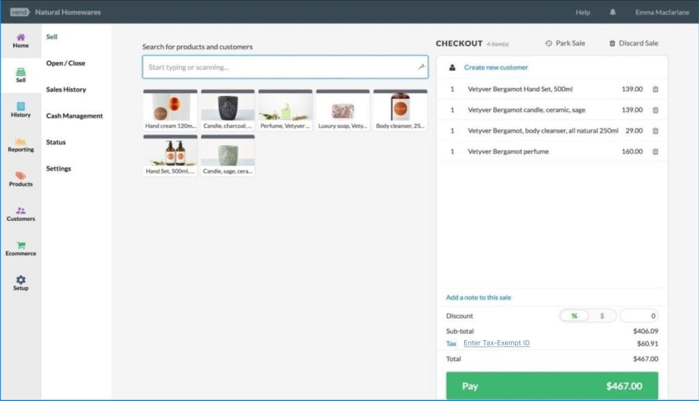
Field Name | Field Type | Required? | Min Char | Max Char | Notes
Enter Tax Exempt ID | Hyperlink | No | N/A | N/A | On click, displays the pop-up for the Cashier to enter Tax-Exempt ID

Wireframe 2:
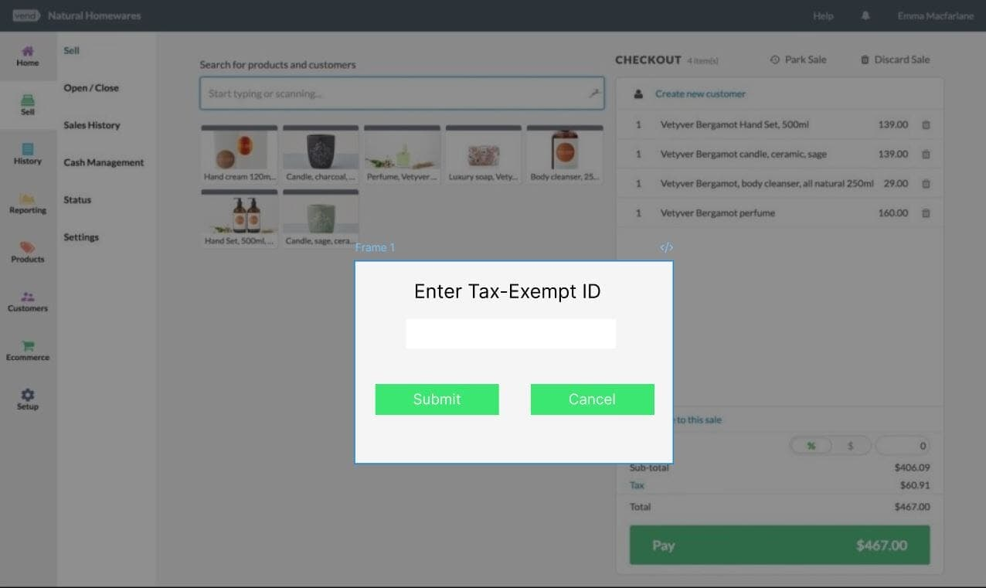
Field Name | Field Type | Data Type | Required? | Min Char | Max Char | Notes
Enter Tax Exempt ID | Text Box | Numeric | Yes | 10 | 10
Submit | Button | N/A | N/A | N/A | N/A | On click, if validation pass:-Displays manager approval pop-up if Tax amount > $50, closes the pop-up
Cancel | Button | N/A | N/A | N/A | N/A | Closes the pop-up

Wireframe 3:
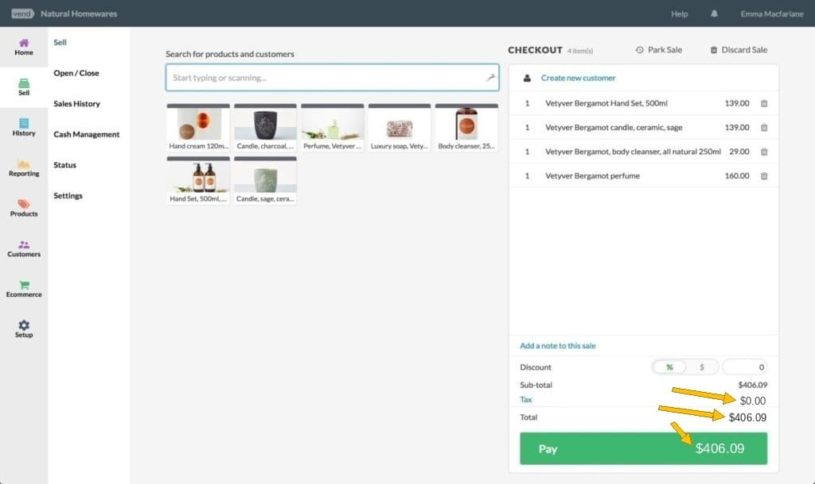

Wireframe 4:
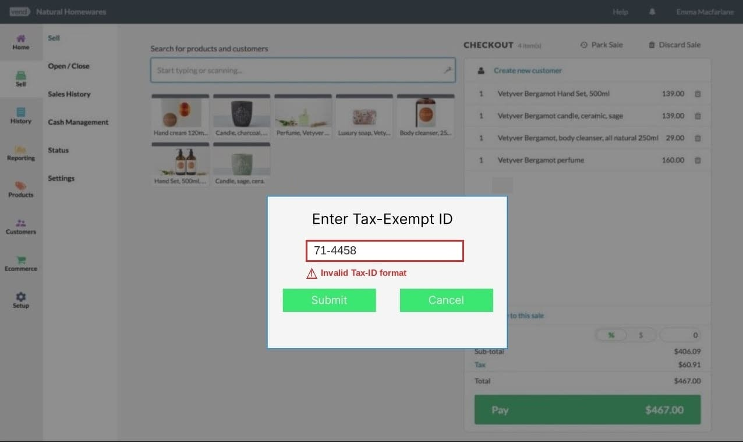

Wireframe 5:
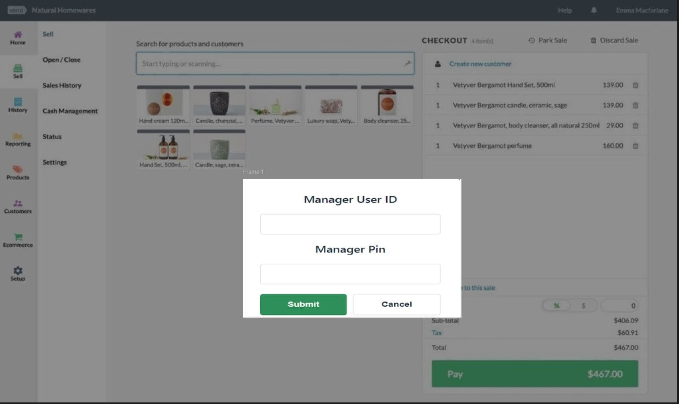
Field Name | Field Type | Data Type | Required? | Min Char | Max Char | Notes
Manager User ID | Text Box | Alpha-Numeric | Yes | 5 | 5
Manager Pin | Text Box | Numeric | Yes | 4 | 4 | Encrypt the entered data
Submit | Button | N/A | N/A | N/A | N/A | On click, if validation pass: Close pop-up else, display error message
Cancel | Button | N/A | N/A | N/A | N/A | Closes the pop-up

Wireframe 6:
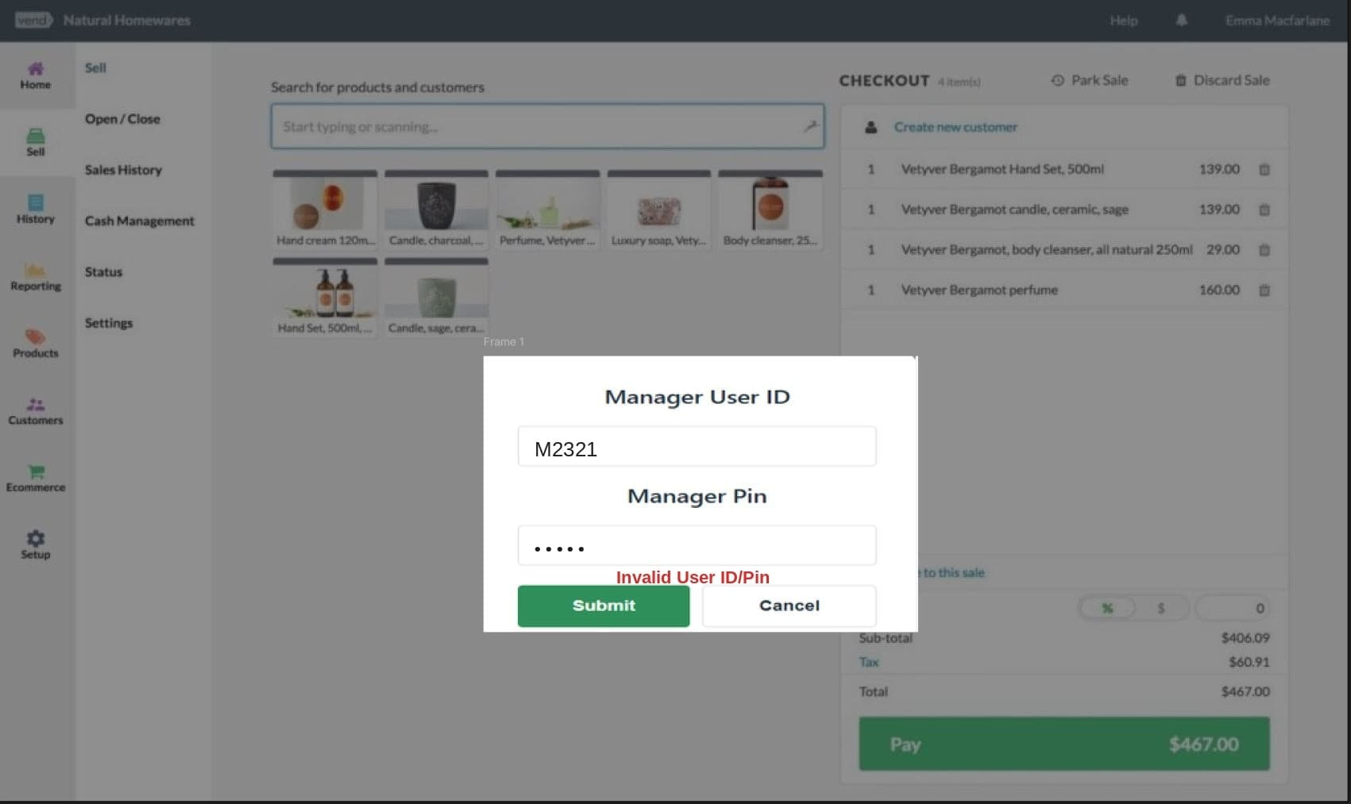

Wireframe 7:


